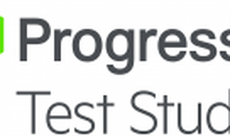



Explore

**Test Studio** is an innovative and easy-to-use automated web, WPF, and load testing solution that ensures web applications behave as expected across different browsers and form factors. [It supports essential technologies like **ASP.NET AJAX, Silverlight, PHP, and MVC**1](https://www.telerik.com/teststudio/web-testing)[2](https://docs.telerik.com/teststudio/welcome).

Here are **five free learning resources** to help you explore Test Studio:

1. [**Telerik Test Studio Documentation**](https://www.telerik.com/support/teststudio): Access detailed documentation, technical resources, and popular community topics to maximize your understanding of Test Studio[3](https://www.telerik.com/support/teststudio).
2. [**ArtOfTesting Tutorials**](https://artoftesting.com/): ArtOfTesting offers free tutorials on various testing topics, including test automation and performance testing tools like Selenium, Katalon Studio, Cucumber, and JMeter[4](https://artoftesting.com/).
3. [**Studiosity Practice Tests**](https://www.studiosity.com/student-resources/practice-tests): While not specifically focused on Test Studio, these practice tests cover various subjects and can enhance your overall testing knowledge[5](https://www.studiosity.com/student-resources/practice-tests).
4. [**Microsoft Learn: Power Apps Test Studio**](https://learn.microsoft.com/en-us/power-apps/maker/canvas-apps/test-studio): Learn about Test Studio’s low-code solution for writing, organizing, and automating tests for canvas apps using Power Apps expressions[6](https://learn.microsoft.com/en-us/power-apps/maker/canvas-apps/test-studio).
5. [**Telerik Test Studio Overview**](https://www.telerik.com/teststudio/web-testing): Explore the official Test Studio page for an overview, demos, and additional resources[1](https://www.telerik.com/teststudio/web-testing).

Happy learning! 🚀